INSTRUCTIONS FOR COMPLETING APPLICATION

Application Form
Make sure you complete the entire application form in the order as it appears. To submit your application:
- Print the pdf application form, complete it and send with all the requested attachments and mail in one complete packet to the Foundation. You can also type the information into the pdf form using Acrobat Reader and print the form, or send it in via email. If you email the form, attach the supporting information to the email.
- Download the Microsoft Word application form, complete it by tabbing from one field to the next. Do not rearrange or add information to the form. All additional information should be added as attachments, not as part of the application form. Once you print the application form, gather all the requested attachments and mail them in one complete packet to the Foundation. You may also email the form and attach the supporting information to the email.

Supporting Information:
Please submit all the materials in the order requested, and as separate copies. You may include additional information with your application that supports your organization’s project, such as brochures, fund-raising flyers, or additional information. You are required to include the following attachments:
- a copy of the IRS certification letter showing organization’s 501 (c) 3 exemption status
- a copy of organization’s balance sheet and profit & loss statement for last 2 years
- an organizational chart with governing body members names, addresses, phone numbers and emails
- a copy of organization’s mission statement and a summary of last year’s service information (if it existed)
- a copy of the firm contract or estimates and a detailed budget for the project
- copies of brochures, advertisements, flyers, etc. that talk about your organization’s purpose, or show other fund-raising initiatives

Submitting Application Packet:
Please mail all the materials in one packet. If you submit the application and materials in various packets, it is possible that your application will not be reviewed in its entirety.
Mail materials to:
Owatonna Foundation
PO Box 642
Owatonna, MN 55060

Email application form and supporting information as attachments to: info@owatonnafoundation.org

Hand deliver materials to:
Owatonna Foundation Office
108 W. Park Square
Owatonna, MN 55060
Office Hours: Monday, Wednesday and Friday 9:00 am – 1:00 pm

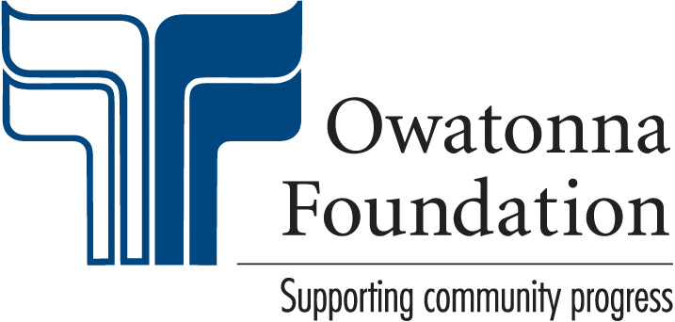 |  |  |  |  | All information on this application must be completed and submitted in the order as it appears on the form.  GRANT APPLICATION
 |  |  |  |  | Date Submitted:
Project Title: |  |  |  |  |  | Amount Requested:
Organization: |  |  |  |  |  | Contact Person:
Address: |  |  |  |  |  | Contact’s Title:
City: |  |  |  |  |  | Phone:
State: |  |  | Zip: |  |  | E-Mail:
Writer (if different than contact): |  |  |  |  |  |  | Writer’s Phone:
Is the organization a 501(c) 3?* Yes No |  |  |  |  |  | Federal ID Number:
* The Owatonna Foundation only awards grants to organizations with 501 (c) 3 status. Attach a copy of the IRS certification letter showing 501 (c) 3 exemption status.
Has the organization ever received a grant from The Owatonna Foundation? Yes No
If yes, what is the approximate total amount of all grants received?

ORGANIZATIONAL INFORMATION
Date established: |  |  | # of full-time employees: |  |  | # of regular volunteers: |  | Dates of fiscal year:
Current year budget: |  | $ |  | Endowment or Reserve Funds: |  |  |  | $
Attach a copy of organization’s balance sheet and profit & loss statement for the last 2 years.
Describe the organization’s source of income:
Has this request been authorized by the organization’s governing body? Yes No |  |  |  |  |  |  |  |  | If yes, when:
Attach an organizational chart and governing body member names and phone numbers.
What other local organizations are active in the same or similar activity(s)?
What is the relationship of this project to the overall program of the requesting organization?
Explain organization’s mission with a description of population served and principal geographic area of service. Attach a mission statement and a summary of last year’s service information if it existed.

PROJECT INFORMATION
Total project budget: | $ | Amount Requested: |  | $ |  | When are the funds needed:
Are the funds being requested designated to be used for capital expense? Yes No
Please list specific expenses for the total that you are requesting:
Have requests for financial support of this project been submitted to other sources for funding?
Yes No If yes, who are they and what amounts have been pledged:
Name the individual(s) in your organization who will be in charge of this project. Please describe their experience with construction contracts and projects.
Describe/Define who will directly benefit from this project?
# of people to be served by this project: |  |  |  |  | Geographical location of project:
Identify the project goals along with immediate and long-range results:
How will the community benefit from this project?
Identify other principle sources of support and/or cooperating organizations:
Please list specific fund raising efforts that have been made and the amounts raised by each AND/OR planned fund raising efforts and the expected results by each effort:
How will you publicly acknowledge The Owatonna Foundation should you receive a grant award?

FINANCIAL INFORMATION
Do you have a firm contract price for the project or do you only have estimates? Firm Estimates
Attach a copy of the firm contract or estimates and a detailed budget for the project.
Have you requested more than one bid for this project? Yes No
The request for funds will be for the following specific items:
Grant Writer’s Signature |  | Head of Organization’s Signature |  | Deadline Date of Project

